**PVC EXTEND in Open Shift.**

IBM_OCP PVC nprd-quay-clair-postgres is nearing full. Data deletion or PVC expansion is required.

**Login to Windows JUMP and login to Cluster Console:**

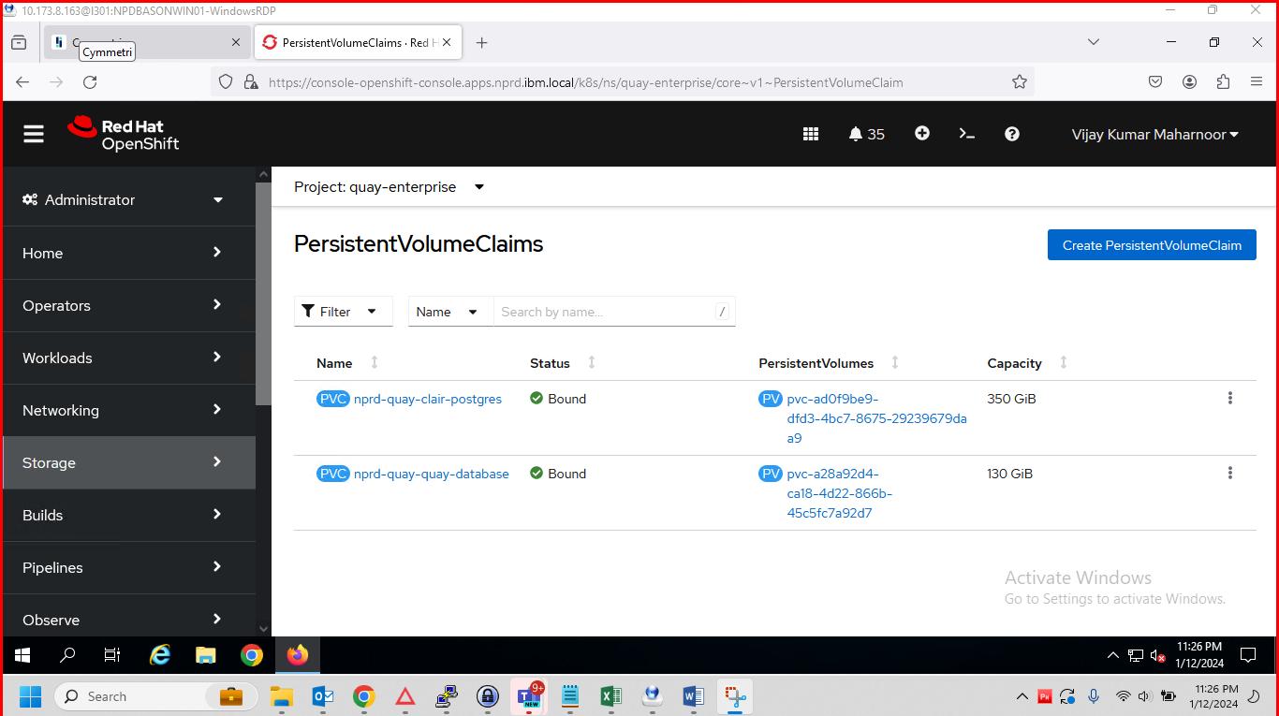

**Go to storage:**

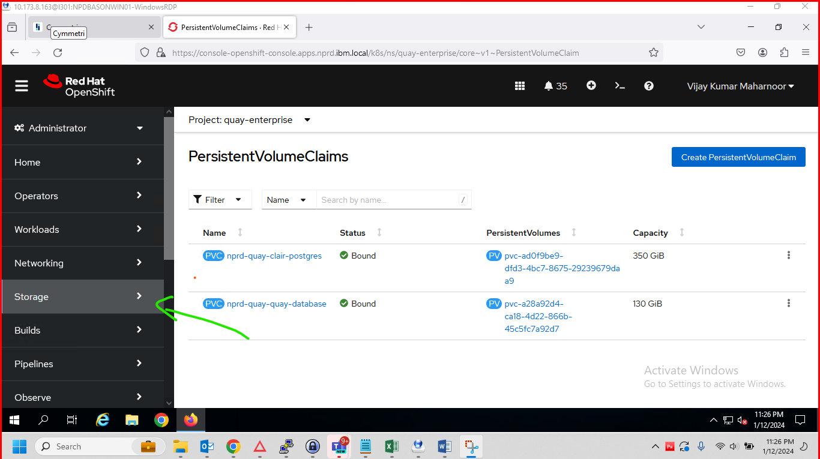

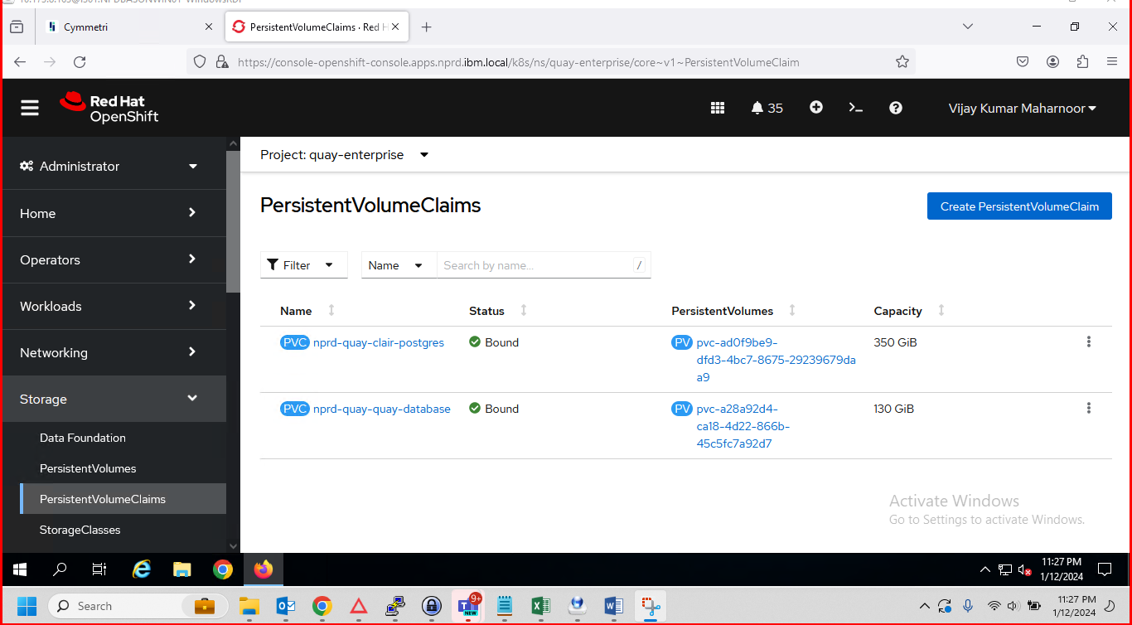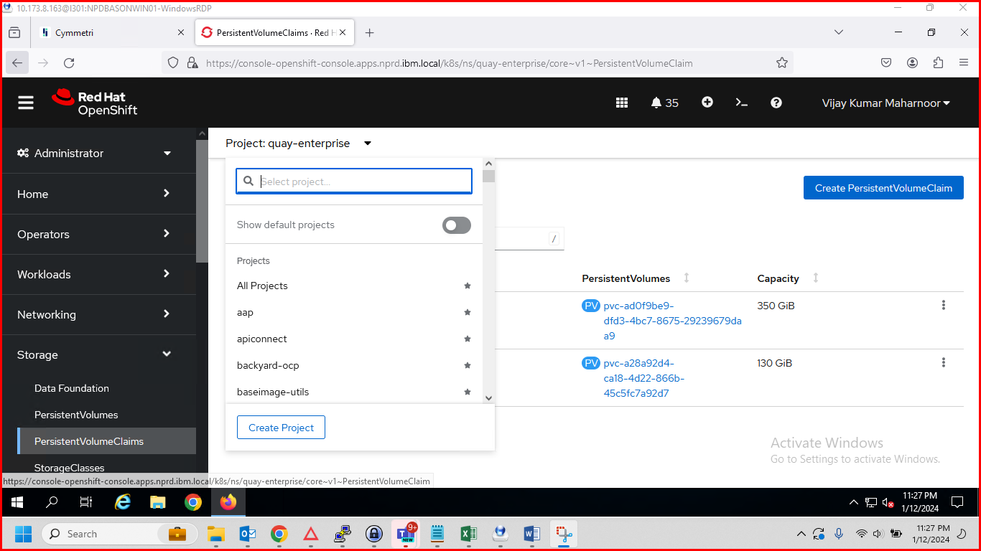

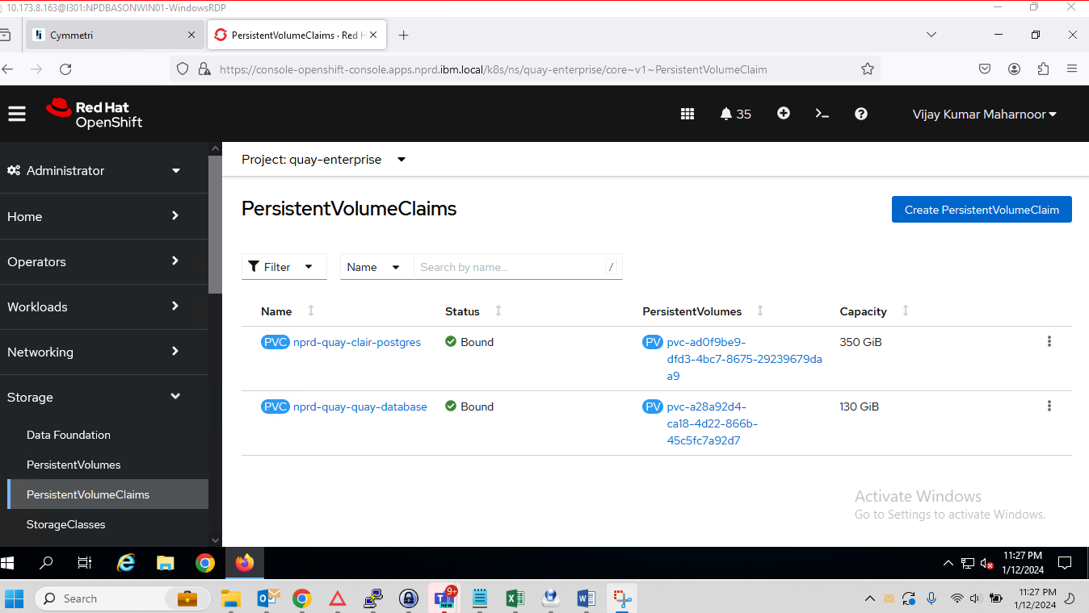

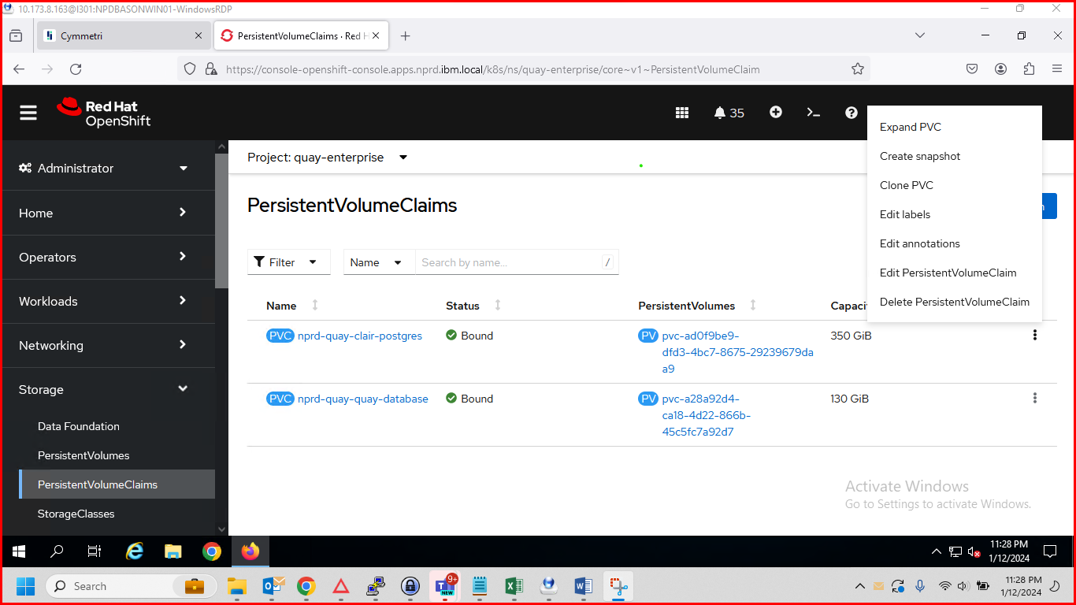

**Please check df –h size of disk from Cluster level.**

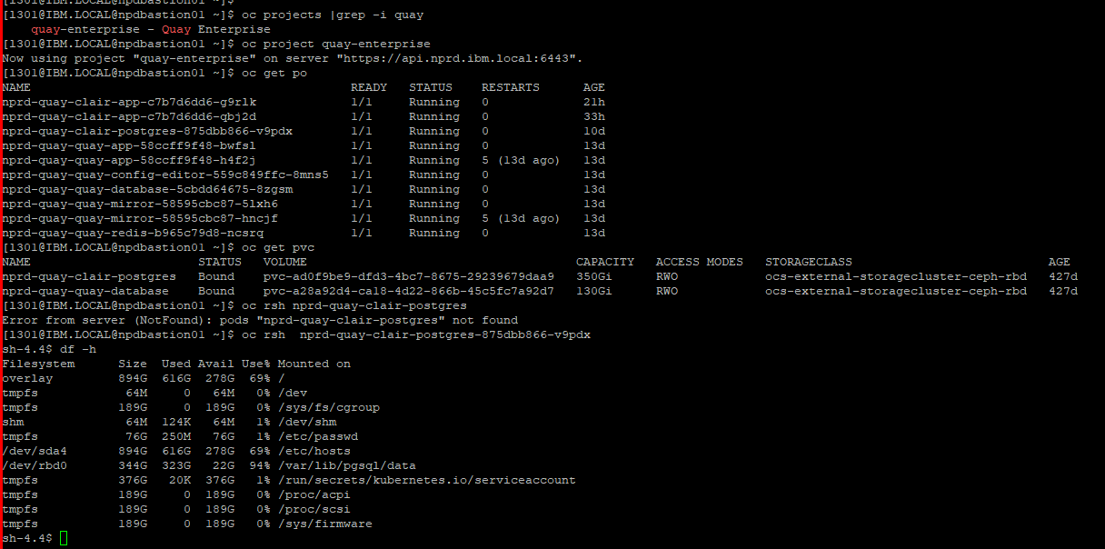

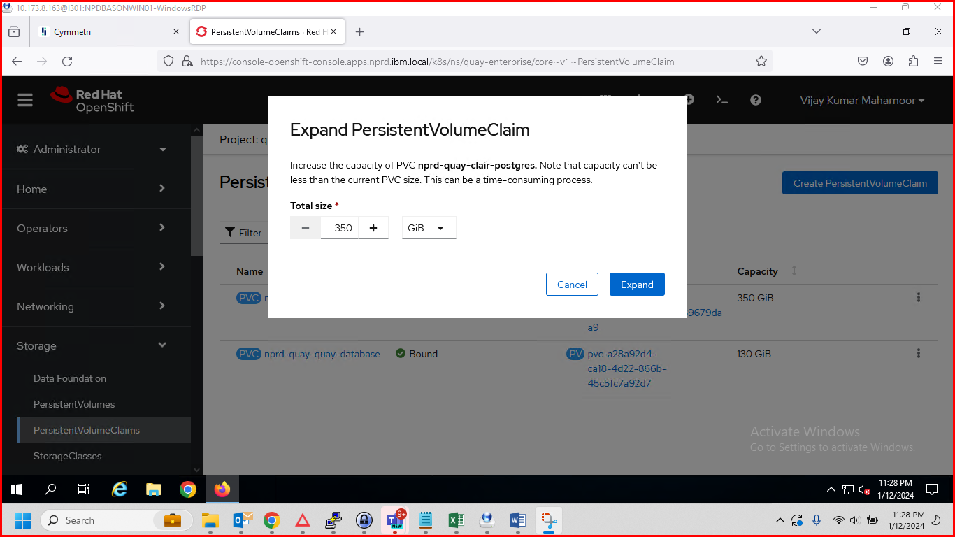

**We can’t reduce the size**

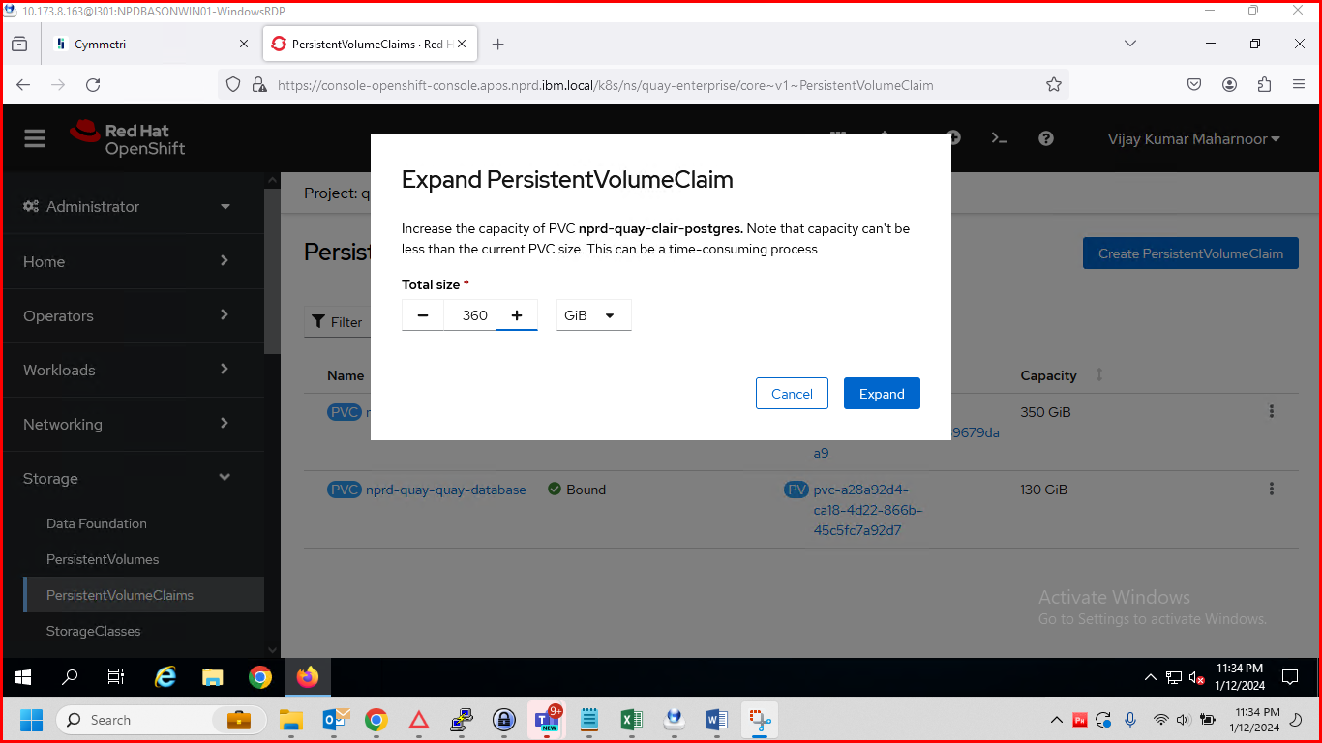

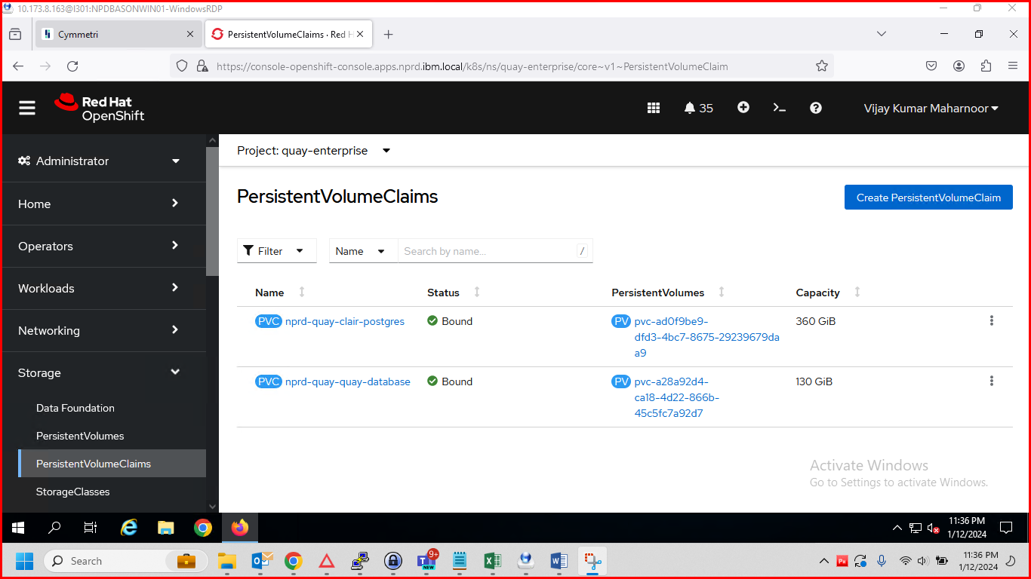

**After Extend:**

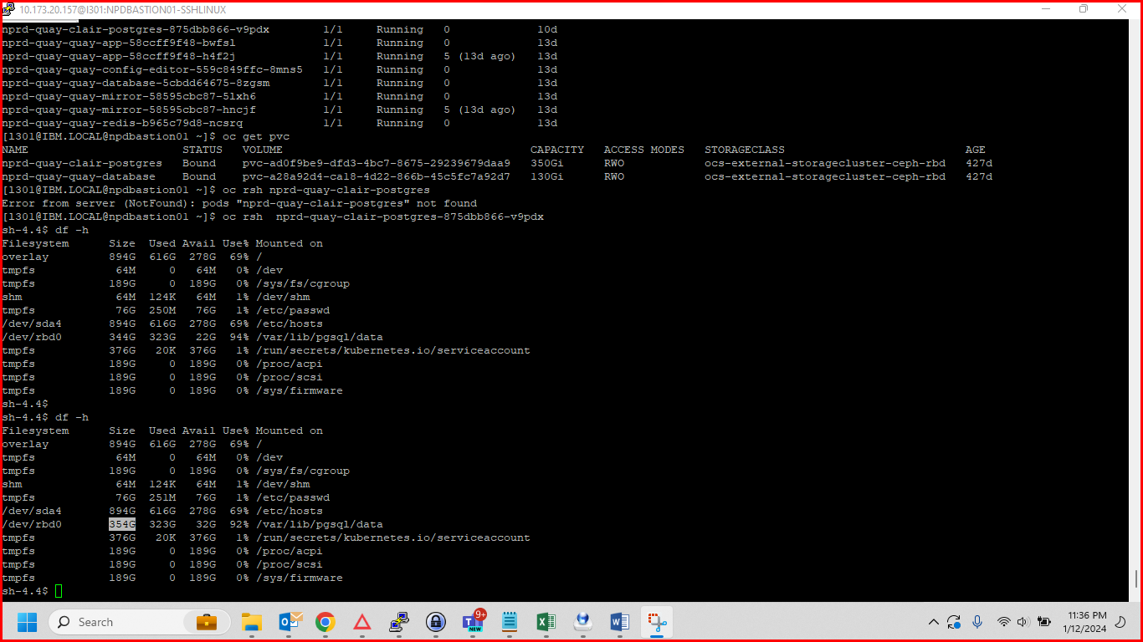

IBM_OCP PVC elasticsearch-elasticsearch-cdm-acc4ej89-2 is nearing full. Data deletion or PVC expansion is required.

